The idea for this UX based on panels comes from wetransfer website so please have a look at it: <https://wetransfer.com> **#1 FIRST SCREEN:**

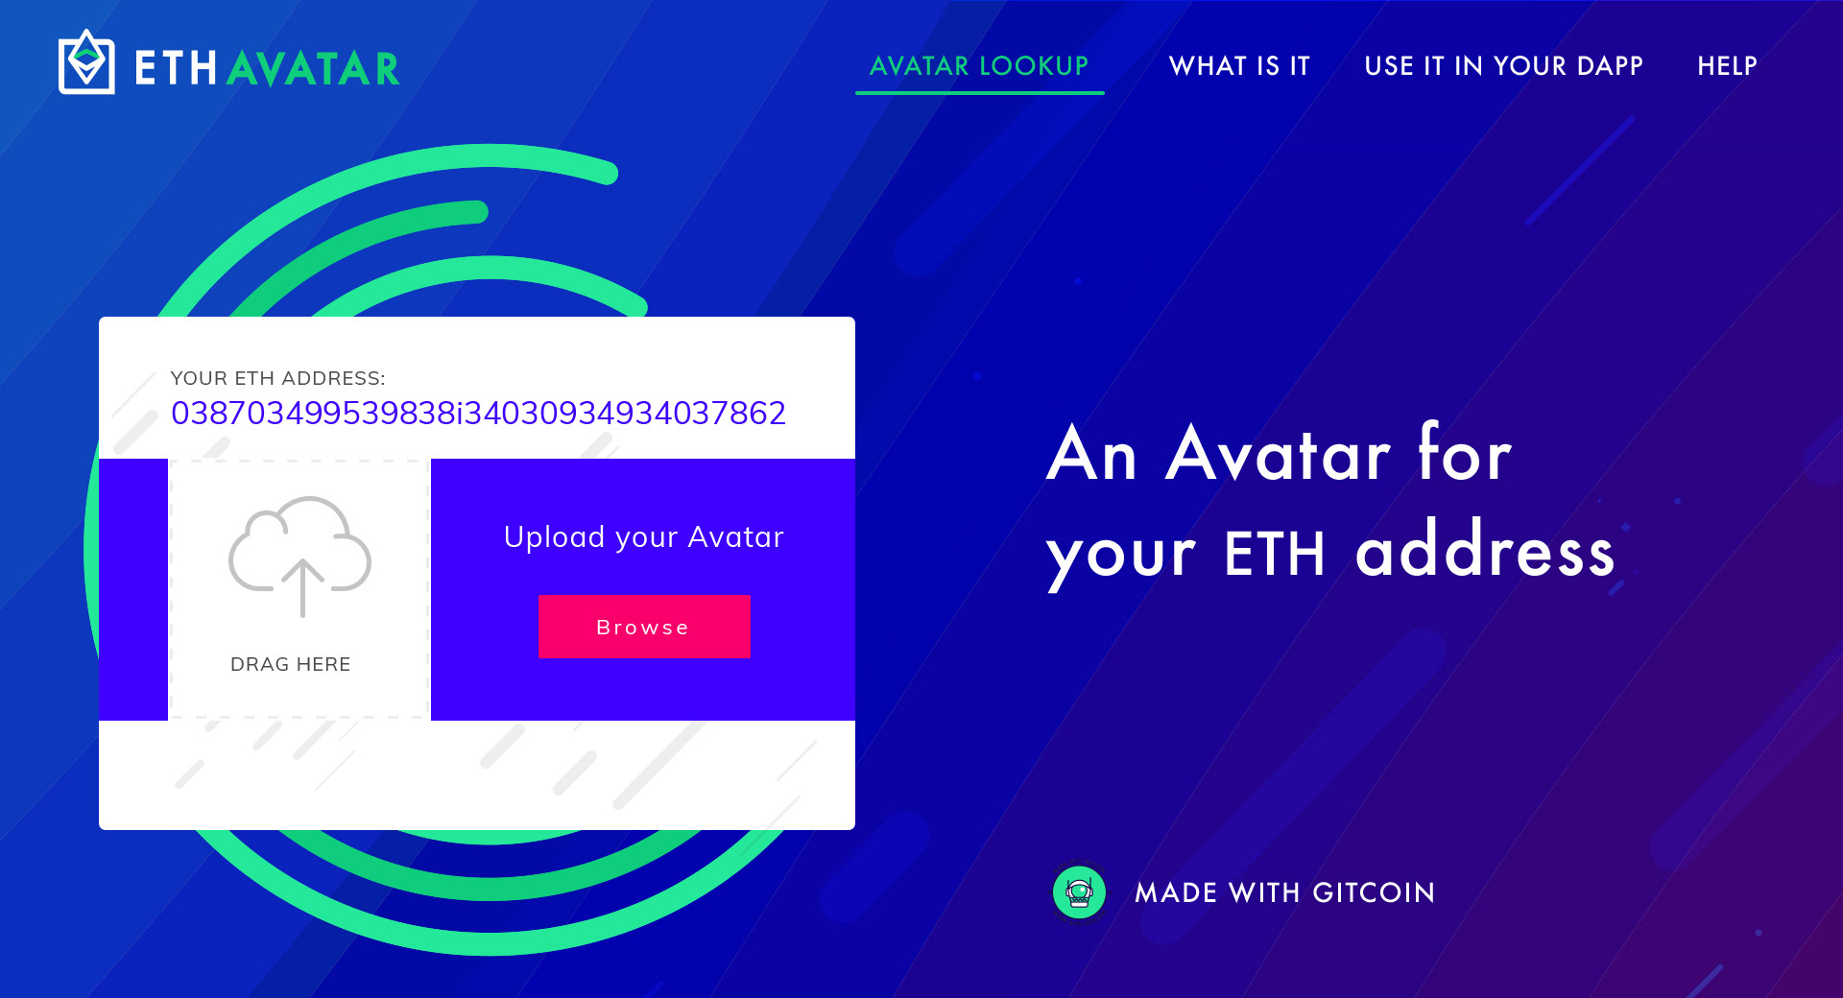

If there is no avatar available for the current address ( I assume the customer is logged in with metamask here)

I imagine this to be a single page application with lots of panels that are opened / closed.   
  
ANIMATION: The main H1 appears from the page load.

ANIMATION: This is just an idea: The green spiral rotating on itself very slowly at 360… even a 15sec long animation if it does not disrupt performance too much. I can also pulsate a little while spinning on itself.

ANIMATION: the arrow in the cloud go up and down, this will help suggesting the user where to start ( the browse / drag&drop functionality ).

HOVER: The avatar lookup will always be green while the rest of the menu remains white but when one of them is selected we can add a nice green line below the selected menu item when we open the panel.

HOVER: Made with Gitcoin it probably deserves a nice touch on hover… a line below the text or an arrow on the right. Also I think we should create an ad hoc badge for the “made for gitcoin” since the current one does not work very well when is used in such a small size.

ANIMATION ON BLUE BACKGROUND: A subtle animation here could be pretty nice like having a few of the bars moving in the background but it’s up to you. Everything should be well balanced and we should not have too many things going on at the same time.

**#2 BROWSE AVATAR:**

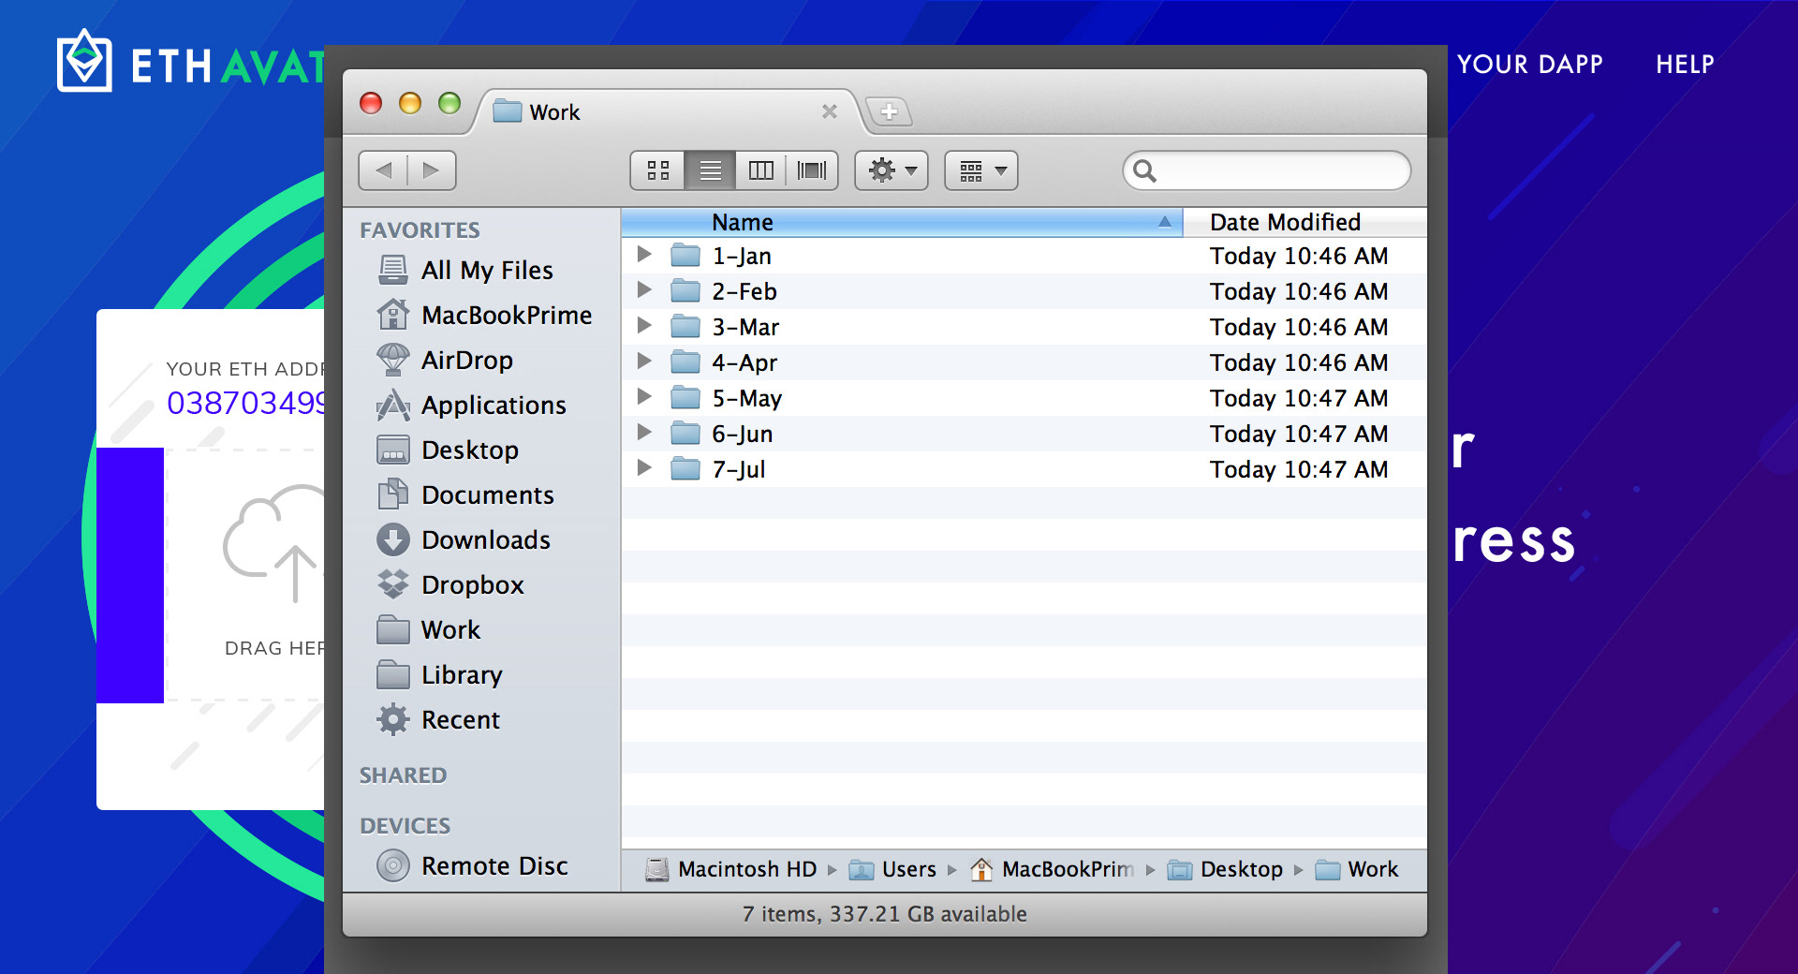

Pretty straightforward. Click on browse or drag a photo from your computer to start the upload from the user side. I have done this screen just to give you a sense of the workflow.

**#3 After “browse image”  
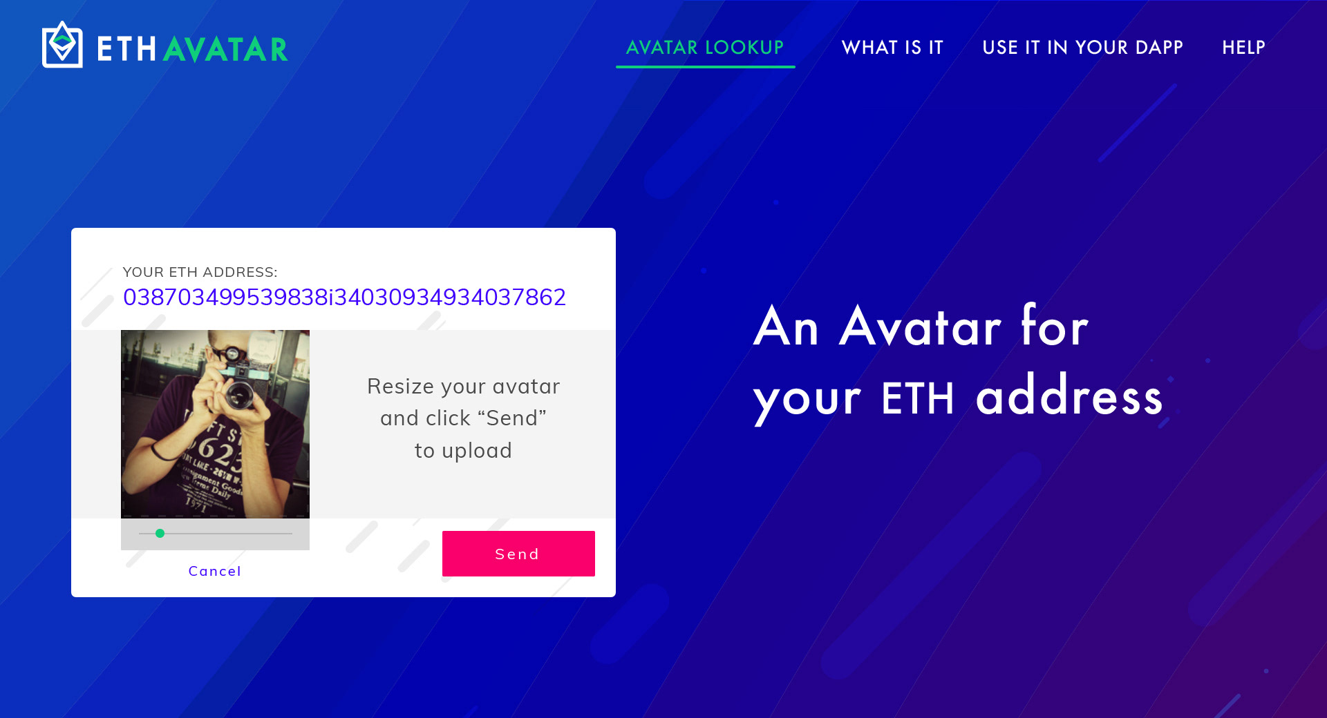**

Immediately after the user selected an image ( no upload on the eth network happened at this point ) we show the photo in the box and a slide bar to resize it.   
I believe that the SEND button can also save the image just before sending it so there is no need for a “save” button at all. The cancel button will just remove the image that you selected.

**#4 Click on send  
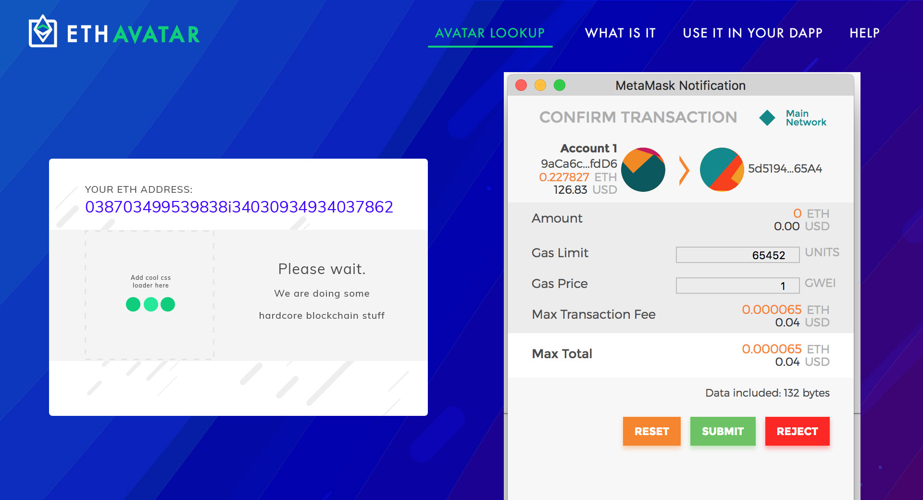**

When the user clicks “send” we open Metamask and let it do its magic. Note that the text change from “resize image” to “please wait” and the avatar is temporary replaced by a loader.   
  
**I think it is very important to swap the avatar with the loader (when the user is on metamask)**: if we have the loader in that area, when the user submit the transaction we can wait a few second and show back the avatar. This will give a sense of accomplishment and tell the user is on the right path. Of course the avatar that we show is still the one in the browser / localstorage because the ETH transaction is not confirmed yet… but from a user perspective their avatar is approved by the blockchain gods in few seconds.

This is a very optimistic approach: We show the avatar like the transaction was successful even if we don’t know it yet. But we can prepare ourself for the worst with this two steps:

1. When we show the avatar we also show a link to check the TX in progress.
2. If we get a rejected transaction, we immediatly update the status of the avatar to reflect that

|  |  |
| --- | --- |
| #4A - CONFIRMED (even if the transaction is not confirmed yet) | #4B - REJECTED ( Worst case scenario ) |
|  |  |

**#5 TOP MENU - about us**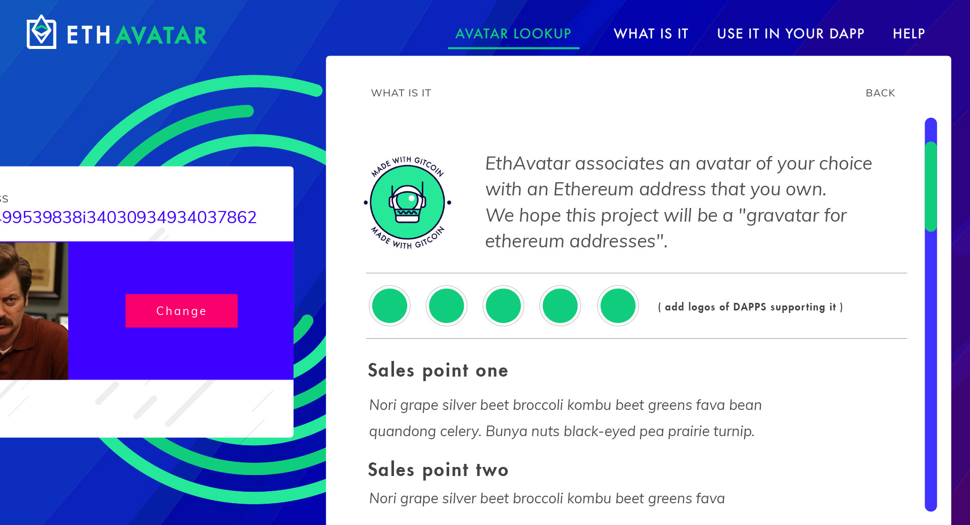

The white links in the top menu will open a white panels ( with scrollbar when applicable) that will slide in from the right. The scrollbar should be tiny and colorful or gray… but not the default scrollbar because it will look ugly and ruin the mood of the site.

When the white panels slide in from the right, it will be pretty cool if it pushed the avatar box to the left and OFFSET it from the screen a little.  
  
A back button will always close the panel and I imagine that if someone click outside on the left of the panel, the panels will be closed as well.

**#6 TOP MENU - use it in your DAPP  
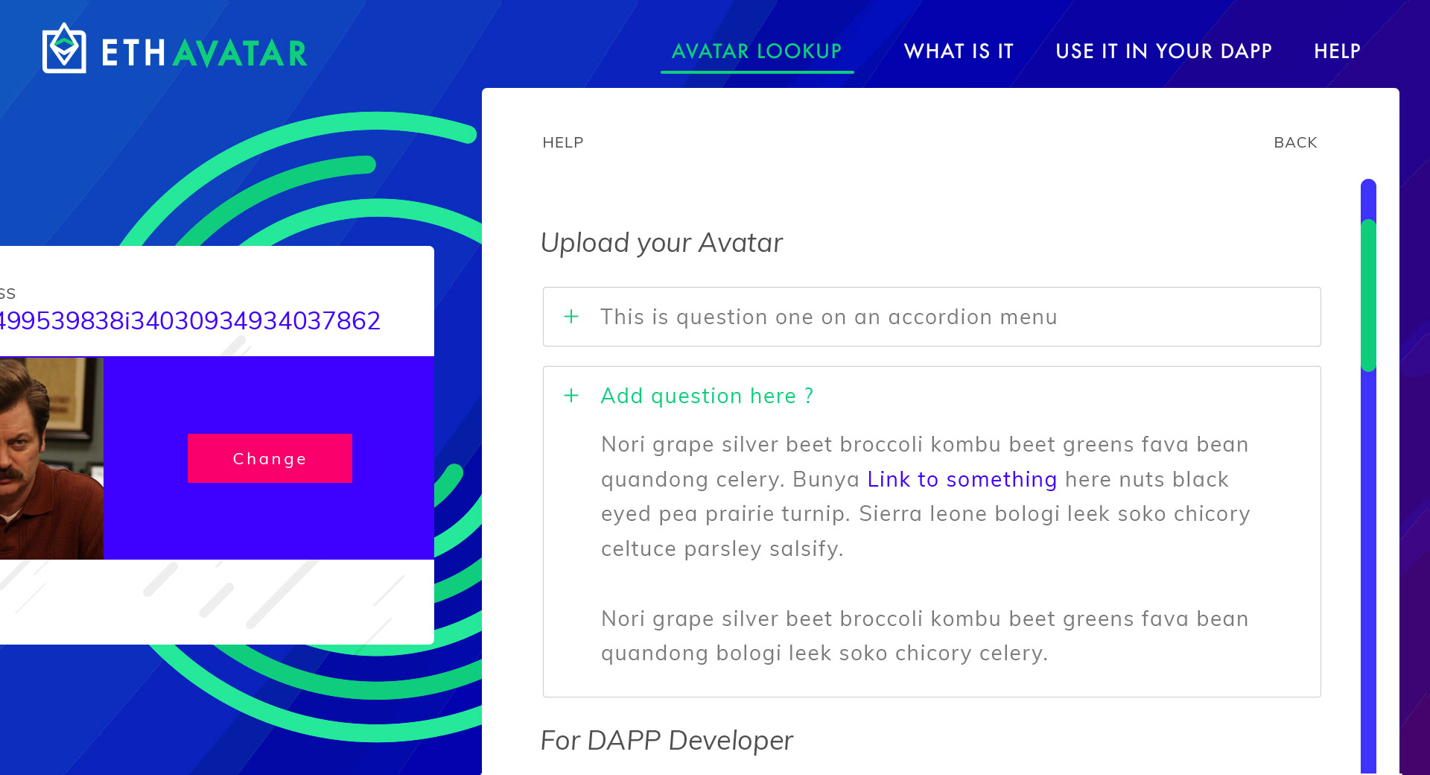**

Nothing very different here, I don’t have the real content for this but I suggest to use FAQ style approach to explain things for devs.

**#7 AVATAR LOOKUP - start  
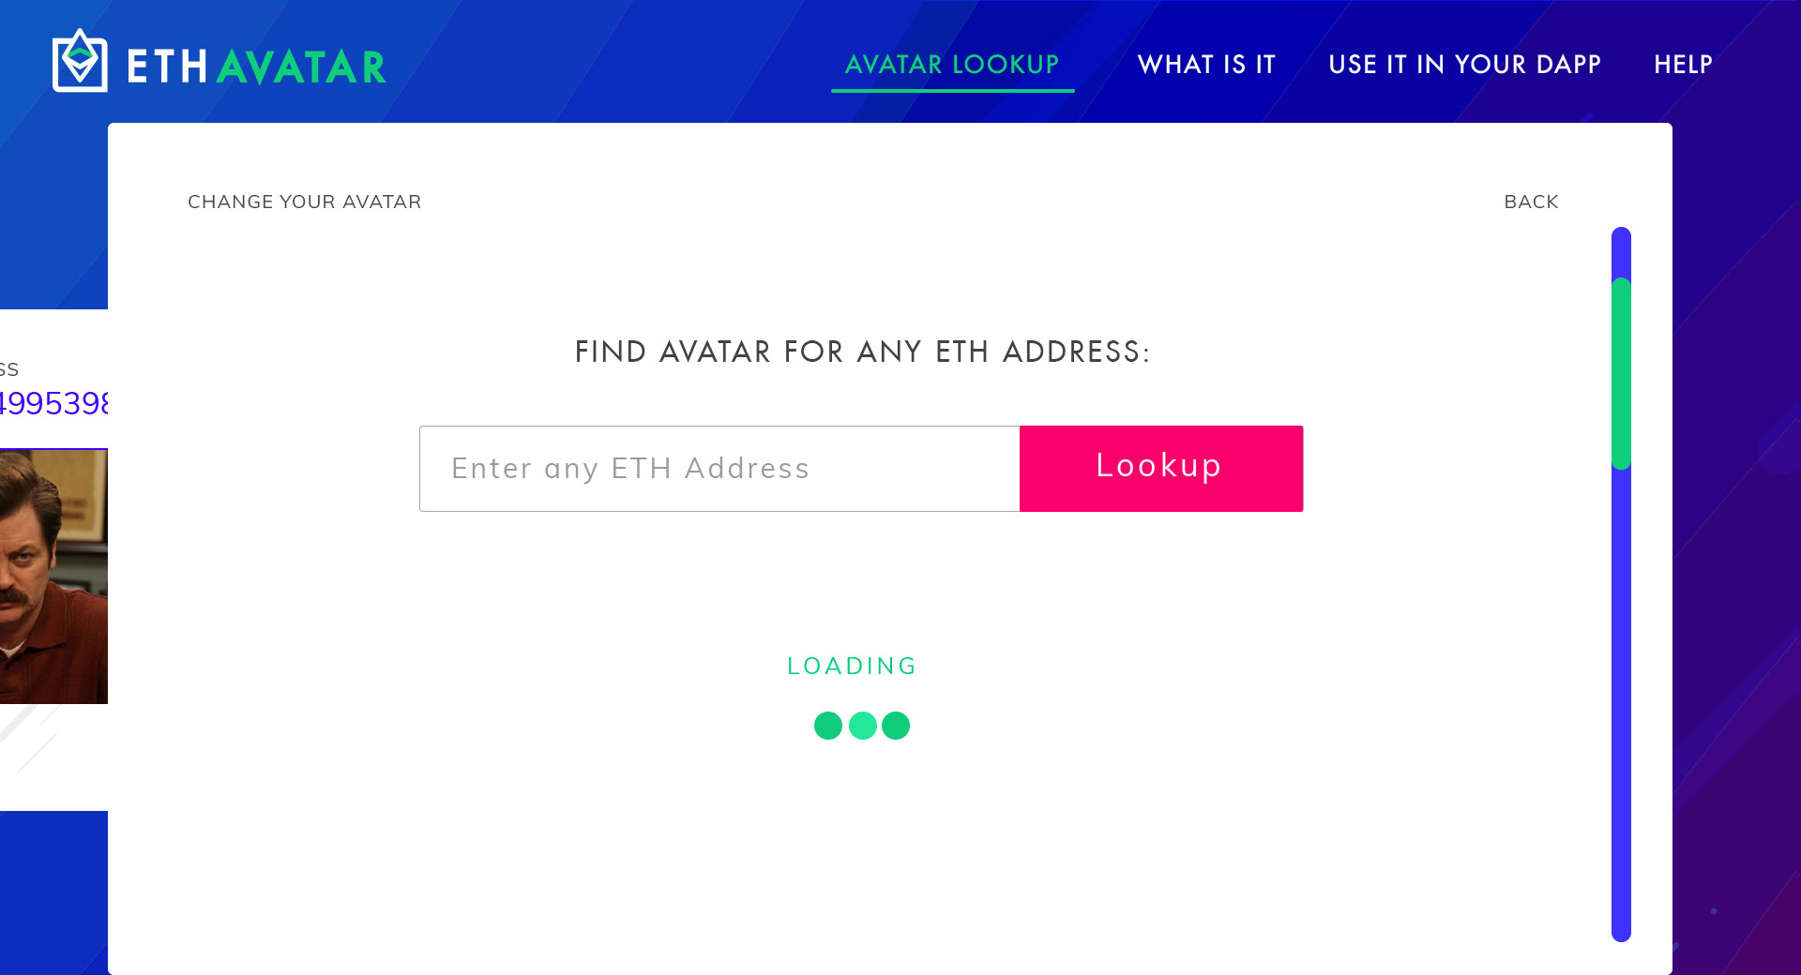**

I have created this panel differently from the others because it’s a different UX experience.  
Ideally this should work even without the ETH network, but I am not sure of the implication of this. If you click on “Avatar lookup” we get this big panel sliding from the bottom.   
   
You can just type any eth address and it will prompt you with the avatar associated to is if available.

**#8 AVATAR LOOKUP - result  
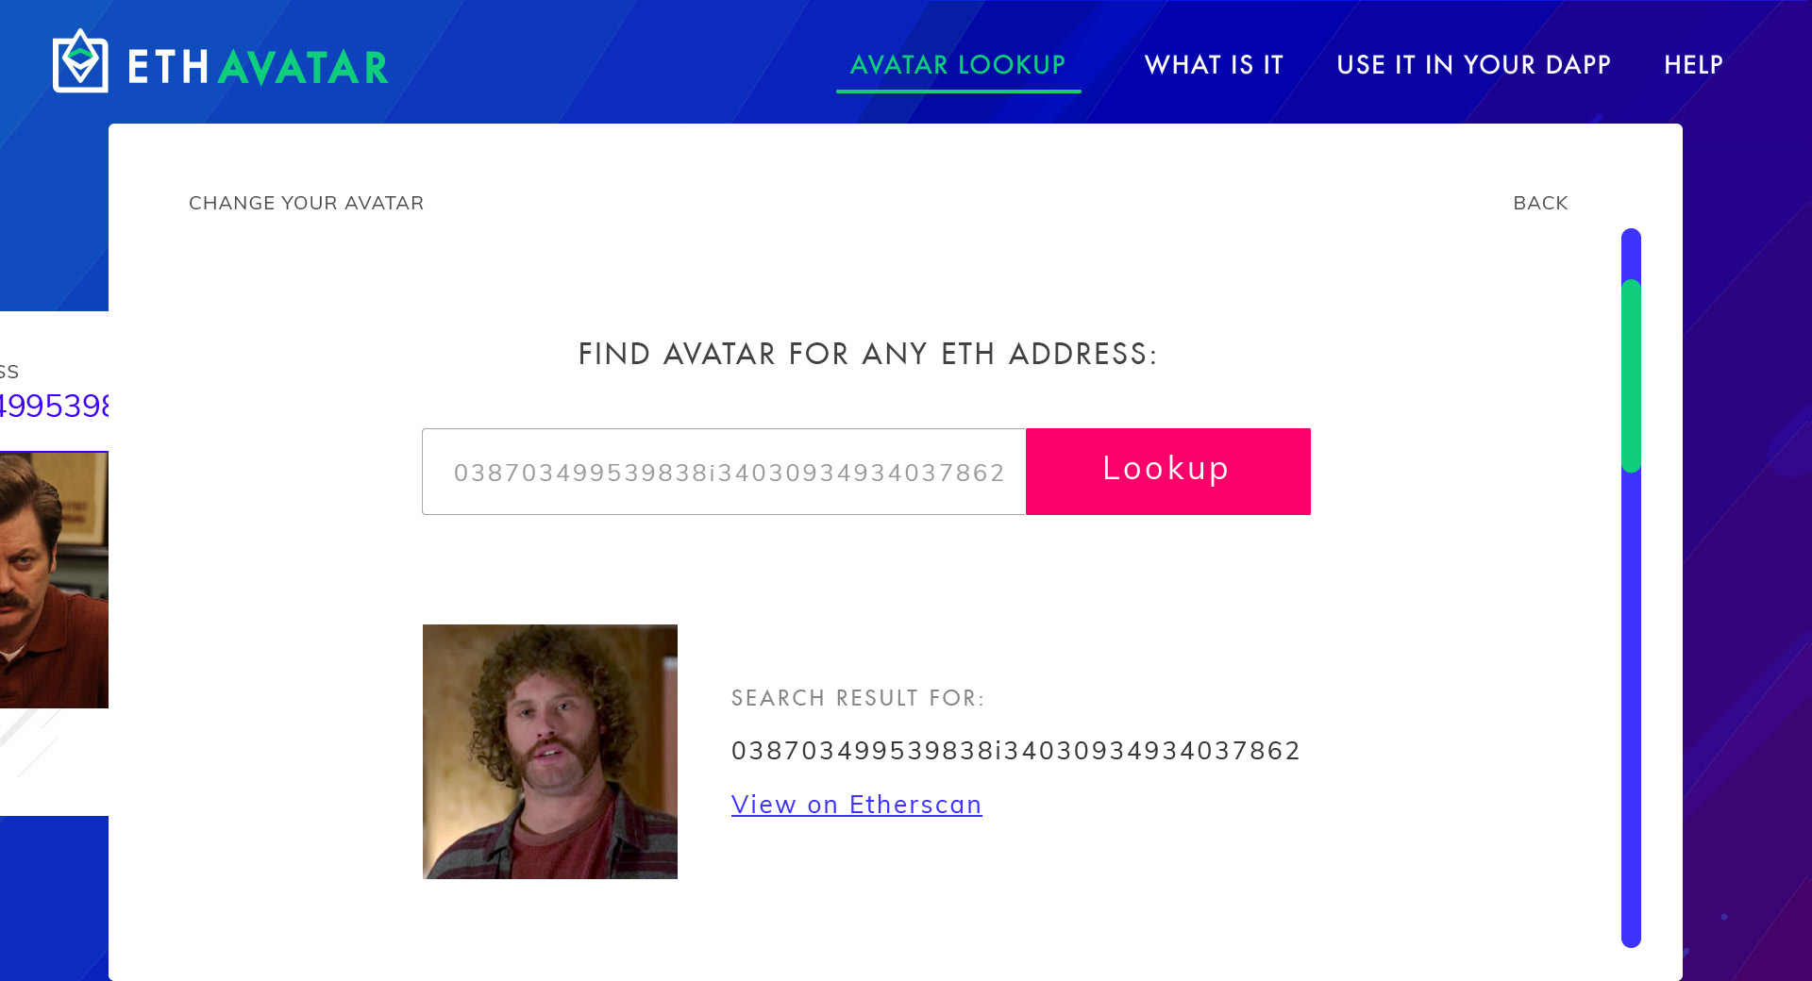**

Example of a result page. Ideally without refreshing the page

**#9 MOBILE  
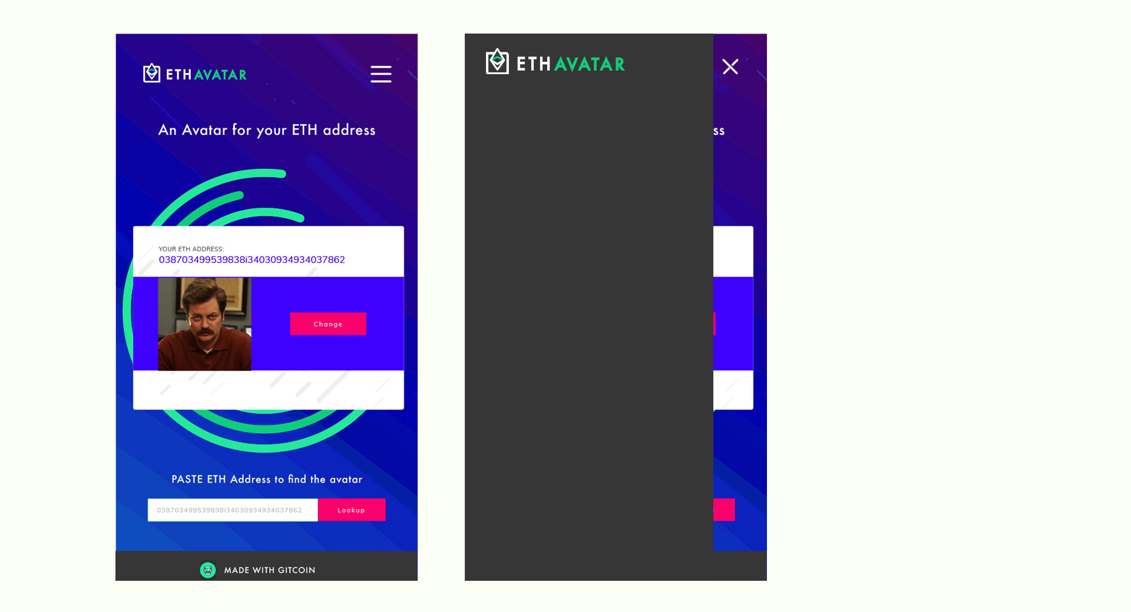**

Given the complexity of the one page DAPP I suggest to keep the mobile Super simple.

Panels will be screens, the top menu links are hidden under the hamburger menu and the the two main workflow navigation are on the page when it starts.  
  
Please note that I have added a gray background to the menu and the footer on mobile, I think it’s a nice touch because the strong visual that works so well on desktop will make the mobile a little ugly I think if we do not guide it in some more rigid shape.

**#10 NO METAMASK  
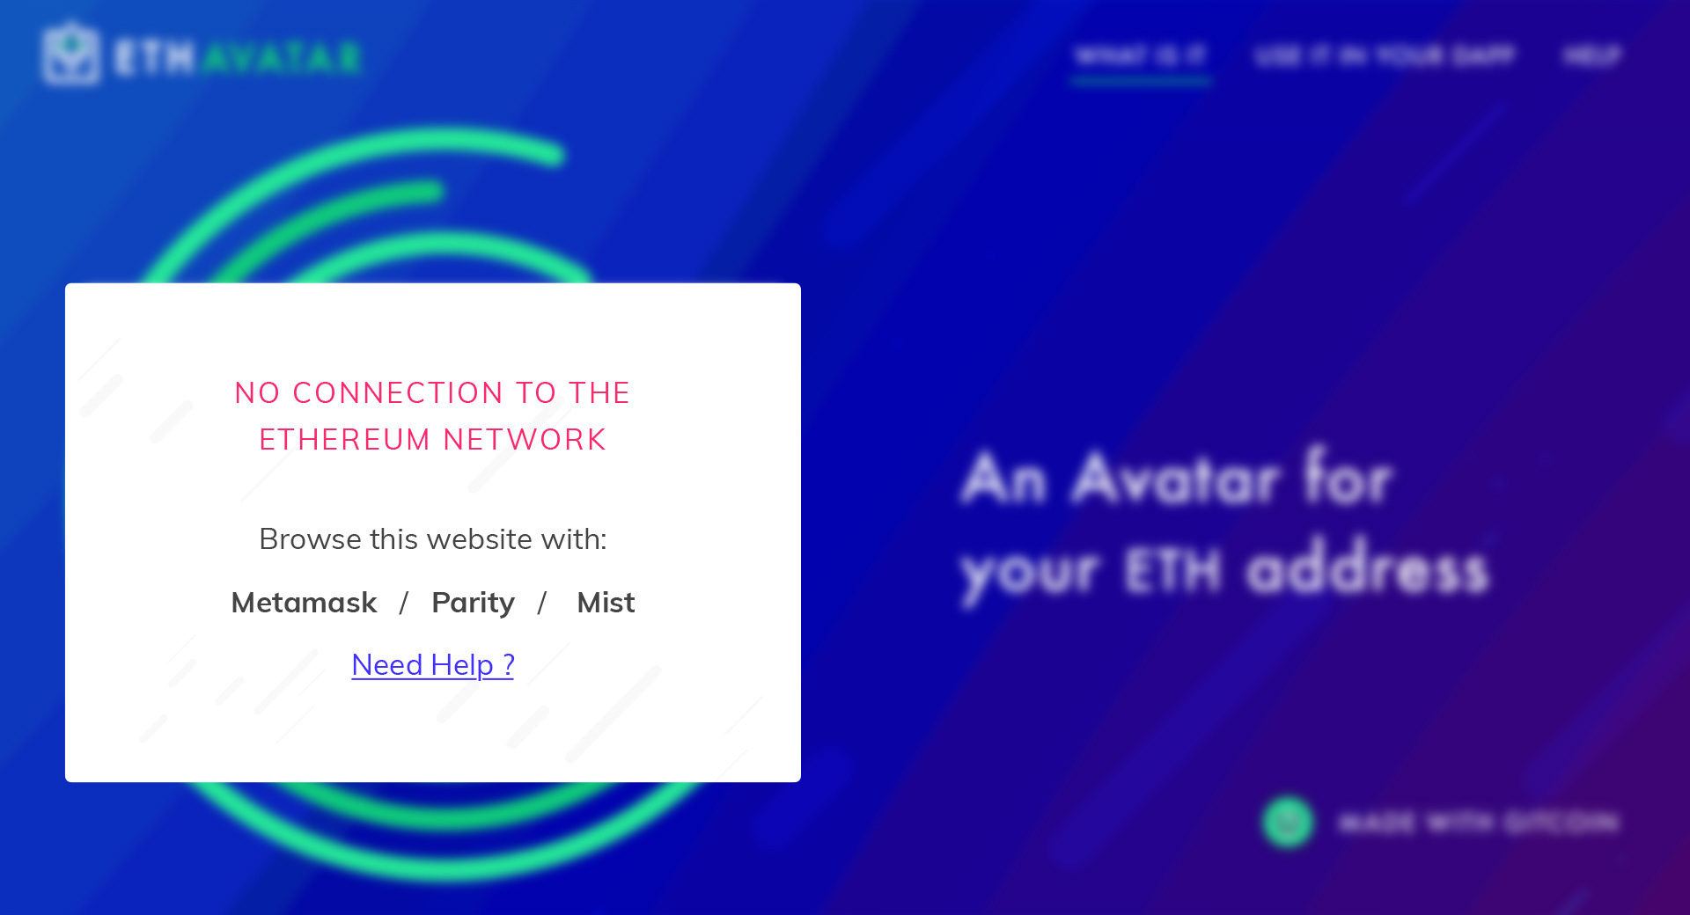**

I like a blur effect but it depends on how much we want to show the user without metamask. We probably want the website to be usable: top menu and eth lookup especially.

**#11 NO METAMASK - help me  
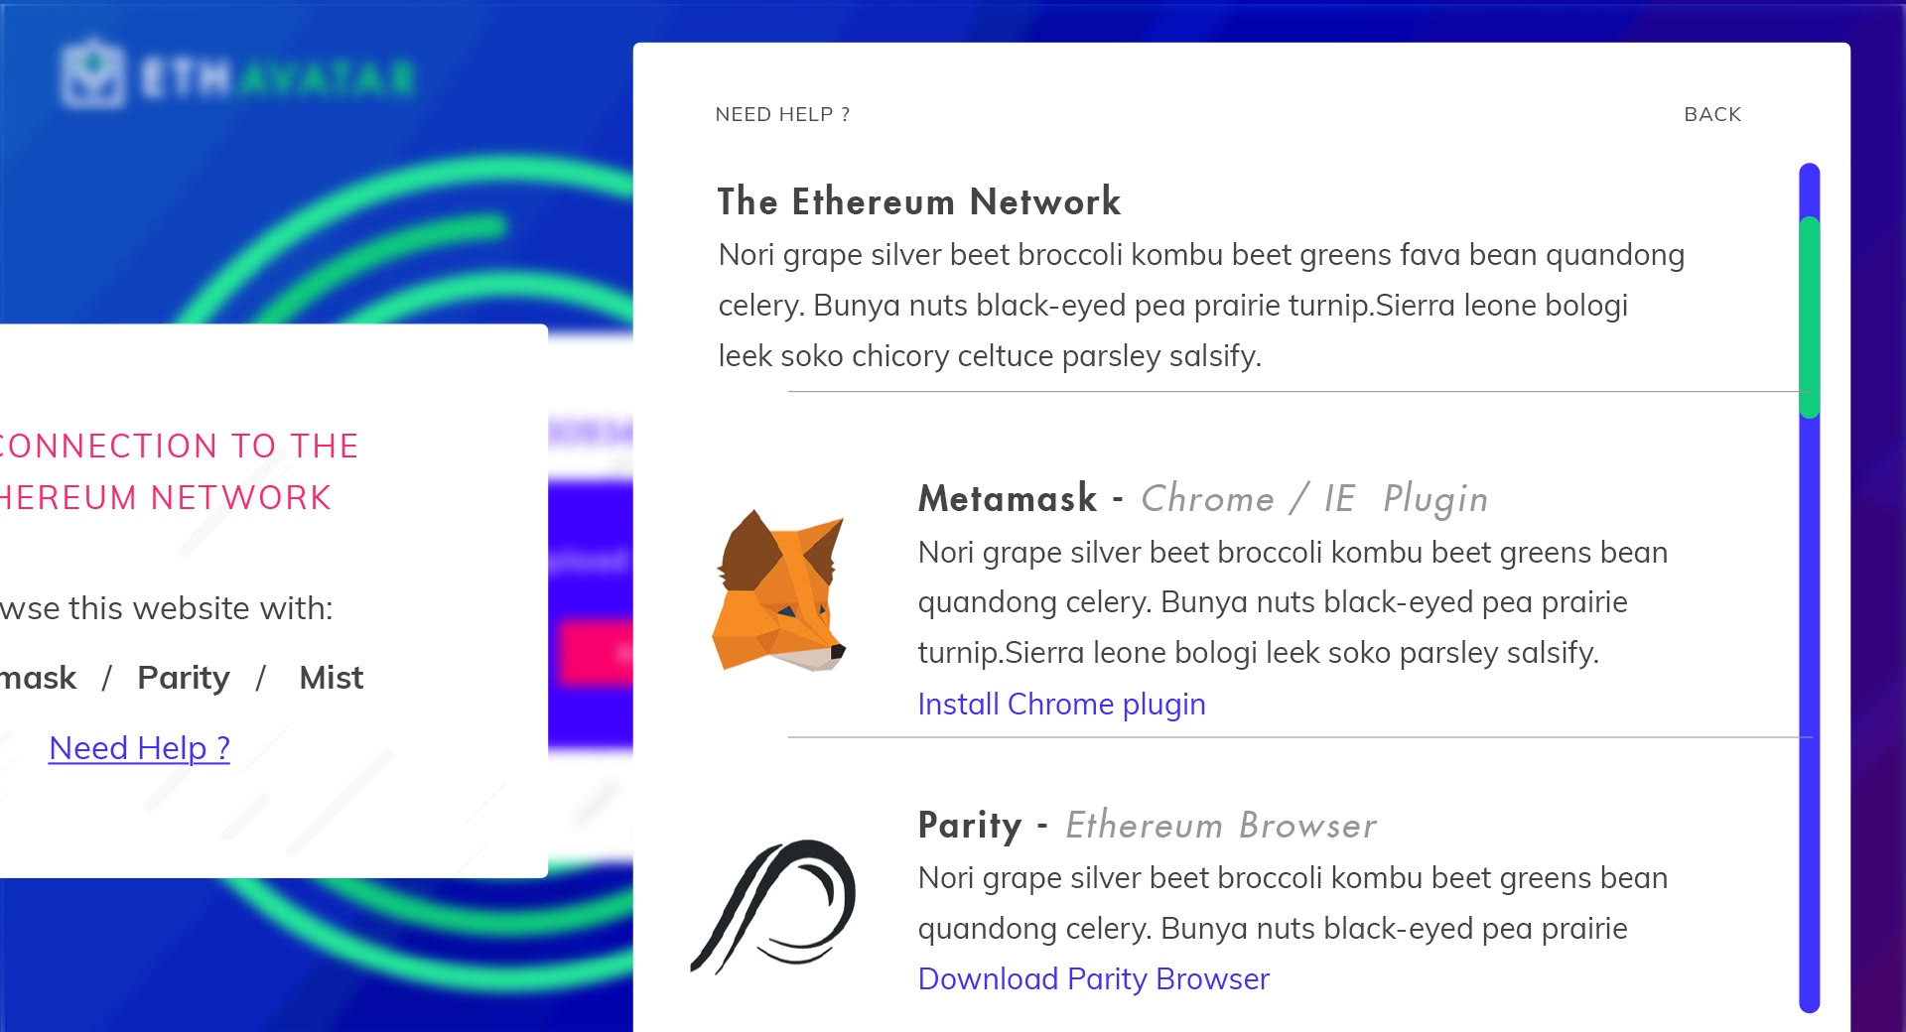**Too many DAPP Forget about this but we should assume that the user just got an eth address one minute ago and than found ETH Avatar. We need to clearly ELI5 them how to use metamask or any ETH browser. I imagine this could be done in a panel.

THE END.